|  | 2814ICT/7003ICT – Data Management / Database Design  School of Information & Communication Technology |
| --- | --- |

**Lab 4.2 Exercise**

**1. Write the MySQL statements.**

For the given MovieCo ERD below, write MySQL statements:

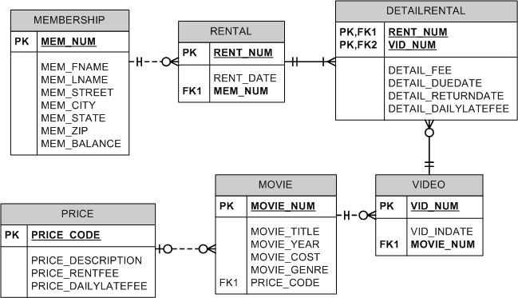

a) List all details about all members.

**Your answer:**

SELECT * from membership ;

b) List all details about price ordered by rent fee in ascending order.

***Hints:***

* Use the ORDER BY clause with PRICE_RENTFEE.

**Your answer:**

SELECT * from price ORDER BY PRICE_RENTFEE ASC

c) List the names of all members in the format FirstName LastName (e.g., Nancy Davolio) and rename the output column as Member Full Name.

***Hints:***

* Use CONCAT function in the SELECT statement to merge member’s first and last names.

**Your answer:**

SELECT MEM_FNAME,MEM_LNAME CONCAT(MEM_FNAME, ' ', MEM_LNAME) Member_full_name from membership

d) List all cities in the membership table in dictionary order but eliminate duplicates. ***Hints:***

* Use the DISTINCT command at the SELECT statement.
* Use the ORDER BY clause with MEM_CITY.

**Your answer:**

SELECT DISTINCT mem_city from MEMBERSHIP ORDER BY MEM_CITY ASC

e) List the video number and other related information from detail rental table for those videos whose return due dates were between 5 and 10 March 2016. Note default date format: ‘YYYY-MM-DD’.

***Hints:***

* Use the WHERE clause, where to compare DETAIL_DUEDATE use either BETWEEN command or comparative operators (<= or >=).

**Your answer:**

SELECT * from DETAILRENTAL WHERE DETAIL_DUEDATE BETWEEN ‘2016-03-05’ AND ‘2016-03-10’